**High Level Design (HLD)**

**Investment Analytics**

**Revision Number - 1.2**

**Last Date of Revision –10/08/2022**

**Kanishka kumar**

H HIGH LEVEL DESIGN (HLD)

**Document Version Control**

|  |  |  |  |
| --- | --- | --- | --- |
| **Date Issued** | **Version** | **Description** | **Author** |
|  |  |  |  |
| 31/07/2022 | 1.0 | Abstract, | Kanishka Kumar |
|  |  | Introduction, |  |
|  |  | General Description |  |
|  |  |  |  |
| 06/08/2022 | 1.1 | Design Detail, KPI, | Kanishka Kumar |
|  |  | Deployment |  |
|  |  |  |  |
| 10/08/2022 | 1.2 | Final Revision | Kanishka Kumar |
|  |  |  |  |

**|** P a g e

I n v e s t m e n t A n a l y t i c s



**3 |** P a g e

HIGH LEVEL DESIGN (HLD)

**2**

**Contents**

Document Version Control…………………………………………………………………………2

Abstract……………………………………………………………………………………………….3

1. Introduction……………………………………………………………………………………….4

1.1 Why this High-Level Design Document?..............................................................4

1.2 Scope……………………………………………………………………………………4

1. General Description……………………………………………………………………………...52.1Product Perspective & Problem Statement…………………………………………5

2.2 Tools Used……………………………………………………………………………...5

1. Design Detail……………………………………………………………………………………...6

3.1 Functional Architecture………………………………………………………………...6

3.2 Optimization………………………………………………………………………….….7

1. KPI……………………………………………………………………………………………….…8

4.1 KPIs (Key Performance Indicators) ……………………………………………..…...9

1. Deployment……………………………………………………………………………………......9

**Abstract**

The practice of evaluating an investment for profitability and risk is known as investment analysis. Its ultimate goal is to determine whether a certain investment is a good fit for a portfolio. It can also range from a single bond in a personal portfolio to a fledgling business investment and even large-scale corporate ventures.

Investment is a game of understanding historic data of investment objects under different events but it is still a game of chances to minimize the risk we apply analytics to find the equilibrium investment.

I n v e s t m e n t A n a l y t i c s



HIGH LEVEL DESIGN (HLD)

**1 Introduction**

**1.1 Why this High-Level Design Document?**

The purpose of this High-Level Design (HLD) Document is to add the necessary detail to the current project description to represent a suitable model for coding. This document is also intended to help detect contradictions before coding and can be used as a reference manual for how the modules interact at a high level.

**The HLD will:**

* Present all of the design aspects and define them in detail
* Describe the user interface being implemented
* Describe the hardware and software interfaces
* Describe the performance requirements
* Include design features and the architecture of the project
* List and describe the non-functional attributes like:

-Security

-Reliability

-Maintainability

-Portability

-Reusability

-Application compatibility

-Resource utilization

-Serviceability

**1.2 Scope**

The HLD documentation presents the structure of the system, such as the database architecture, application architecture (layers), application flow (Navigation), and technology architecture. The HLD uses non-technical to mildly-technical terms which should be understandable to the administrators of the system.

**2 General Description**

I n v e s t m e n t A n a l y t i c s **5 |** P a g e



HIGH LEVEL DESIGN (HLD)

**2.1 Product Perspective & Problem Statement**

The goal of this project is to analyse to predict thefind the equilibrium investment and the practice of evaluating an investment for profitability and risk is known as investment analysis. Its ultimate goal is to determine whether a certain investment is a good fit for a portfolio. It can also range from a single bond in a personal portfolio to a fledgling business investment and even large-scale corporate ventures.

Investment is a game of understanding historic data of investment objects under different events but it is still a game of chances to minimize the risk we apply analytics to find the equilibrium investment.

**2.2 Tools used**

Business Intelligence tools and libraries works such as NumPy, Pandas, Matplotlib, MS-Excel, Tableau, Jupyter Notebook and Python Programming Language are used to build the whole framework.

|  |  |
| --- | --- |
|  |  |
|  |  |
|  |  |

* Jupyter Notebook is used as IDE.
* Python is the Programming Language used.
* EDA is done using Numpy& Pandas.
* Visualizations were done using Matplotlib.
* Tableau is used for dashboard creation.

**3 Design Details**

**3.1 Functional Architecture**

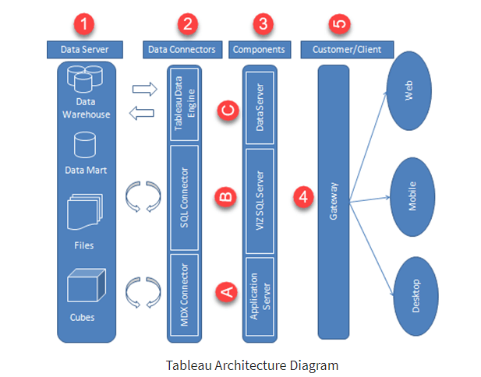

### How does Tableau Work?

* The architecture of Tableau Server is designed to connect different data sources securely.
* Data Server is the first layer in the architecture. It helps Tableau to connect data in various heterogeneous environments.
* Data connector is the second layer. It helps to connect to various databases using its ODBC connector.
* Tableau can connect the real time live data by connecting the database directly. It can also extract a local copy of data through its in-memory data store for faster processing.
* The components such as Application Server, VizQL Server, and data server act as the third layer.
* The application server is used for authentications and authorizations.
* VizQL is used to convert the SQL query into visualizations.
* Data Server is a centralized data management system used in the architecture.
* A gateway is used to distribute the processes into different components.
* The fourth layer of the architecture are the clients such as Tableau Desktop, web and Mobile.

**Assumptions**

It is a task that is trivially performed by investor analyst to analysis on the previous historic 17 years dataset and find the equilibrium investment.

Our analysis assumes that all the data provided was true without any corruption and the features mentioned in the raw dataset are the only driving factors of aequilibrium investment.

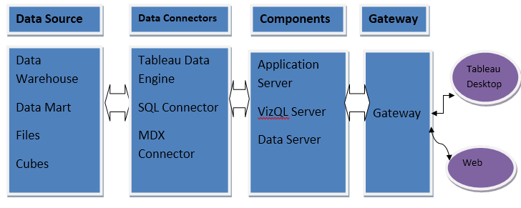

HIGH LEVEL DESIGN (HLD)

**3.2 Optimization**

1. **Your data strategy drives performance**
   * Minimize the number of fields
   * Minimize the number of records
   * Optimize extracts to speed up future queries by materializing calculations, removing columns and the use of accelerated views
2. **Reduce the marks (data points) in your view**
   * Practice guided analytics. There’s no need to fit everything you plan to show in a single view. Compile related views and connect them with action filters to travel from overview to highly-granular views at the speed of thought.
   * Remove unneeded dimensions from the detail shelf.
   * Explore. Try displaying your data in different types of views.
3. **Limit your filters by number and type**
   * + Reduce the number of filters in use. Excessive filters on a view will create a more complex query, which takes longer to return results. Double-check your filters and remove any that aren’t necessary.
     + Use an include filter. Exclude filters load the entire domain of a dimension while including filters do not. An include filter runs much faster than an exclude filter, especially for dimensions with many members.
     + Use a continuous date filter. Continuous date filters (relative and range-ofdate filters) can take advantage of the indexing properties in your database and are faster than discrete data filters.
     + Use Boolean or numeric filters. Computers process integers and Booleans (t/f) much faster than strings.
     + Use parameters and action filters. These reduce the query load (and work across data sources).

HIGH LEVEL DESIGN (HLD)

**Performance**

Investment analytics determines the historic all the previous dataand it should be as accurate as possible. So that it will not mislead to the future investor. Also, model retraining is very important to improve the performance.

**Security**

Since the investment care analysis consists of years data, the information should be secured.

**Reusability**

The code written and the components used should have the ability to be reused with no problems.

**Resource utilization**

When any task is performed, it will likely use all the processing power available until that function is finished.

**4 KPI**

Dashboards will be implemented to display and indicate certain KPIs and relevant indicators for the Investment.

|  |
| --- |
|  |

As and when the system starts to capture the historical/periodic data for a Year, the dashboards will be included to display charts over time with progress on various indicators or factors

**4.1 KPIs (Key Performance Indicators)**

Key indicators displaying a summary of the Investment Analysis and its relationship with different metrics

1. Sector wise investment, Total no of sectors
2. Which sector has maximum or minimum investment

Same as Year wise, Total no of Years.

**5 Deployment**

Tableau prioritizes choice in flexibility to fit, rather than dictate, your enterprise architecture. Tableau leverage your existing technology investments and integrate them into your IT infrastructure to provide a self-service, modern analytics platform for your users. With on-premises, cloud, and hosted options, there is a version of Tableau to match your requirements.

The Dashboard is published on Tableau and an auto-refresh mode has been set so that the dashboard keeps on updating as the real time data loads into the log file.

The Dashboard showcases the multiple insights that has been drawn from the log files as follows:

1. **Sector wise-**This dashboard contains sector wise investment analytics on dataset like total sectors, sectors name and after choosing any sector and see the investment.
2. **Year wise:** This dashboard shows year wise analytics on given dataset.

**Sector Wise Investment Analysis**

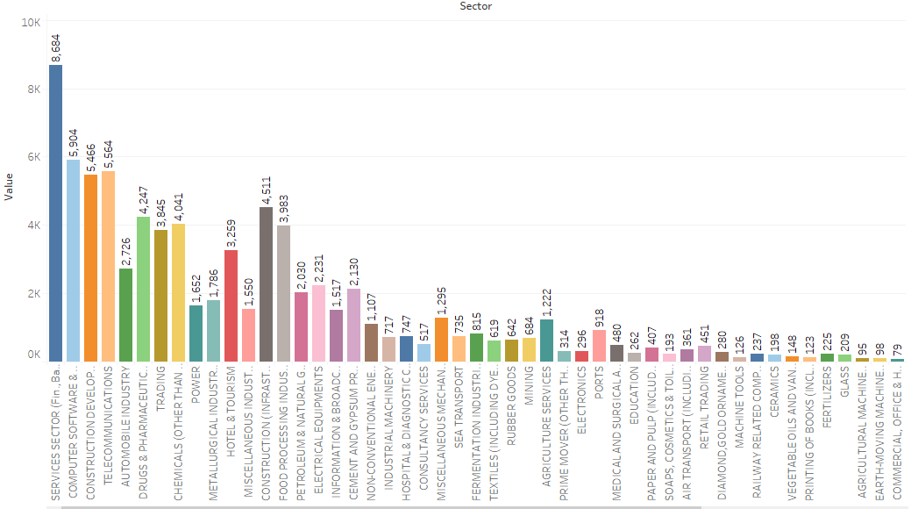

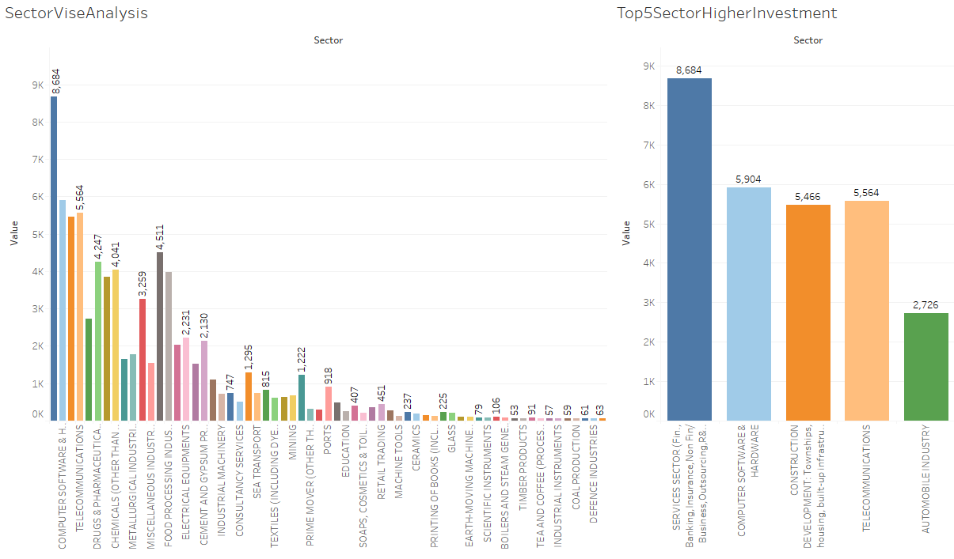

**Year Wise Investment Analysis**

